**EASTER NEWSLETTER**

**April 2021**

Like so many charities, the Corona virus has had a devastation affect on everyone within the Darlington Town Mission family. Friends are continuing to bear the impact of additional isolation from their family and friends, volunteers are missing the wonderful social occasions of our monthly outings and our Missioners are continuing with their work of keeping in touch with Friends, buy only by telephone calls. Our financial situation is only just keeping its head above water thanks to some imaginative fundraising events and kind donations that have been made. We benefit from those that shop on-line and use the ‘Give as you Live’ and ‘Smile Amazon’ links but use of these services is limited. further details can be found on the Missions Website [www.darlingtontownmission.org.uk](http://www.darlingtontownmission.org.uk).



Easter is a time for new beginnings and fresh hope. I pray that the level of restrictions on our freedom is beginning to ease and that we can once more consider meeting face to face again. Having said that, there is still no news about being able to re-start our programme of monthly outings or our other regular events at the Friend’s Forum or as guests at The Well lunch club. We hope that ‘normal service will be resumed as soon as possible’. Before then may I wish you a blessed and safe Easter. Don’t eat too many Easter eggs and keep smiling!

***Brian Simpson***

DTM Chair and Acting Secretary

**Giving**

Unexpectedly, out of the blue,

she said,

“I’ve got a present for you”

It wasn’t my birthday,

there was no special occasion,

It was just a generous impulse,

“I saw it and thought you would like it”

And we looked at each other and laughed.

A moment of sheer delight – a realization of the mutual affection

that had matured through the years of shared experience

the gift itself didn’t matter, but the giving said,

“I love you”

And there has been so much giving and receiving over the years,

Not gifts that you can buy –

how can you buy laughter or tears, patience, or caring,

or loyalty, or time?

*They are without a price*

By Frank Topping

**Easter Greetings from our Missioners**

As we write we are delighted to see signs of spring upon us with all the beauty and signs of new life and hope it brings!

There is nothing more wonderful than seeing snowdrops, daffodils, crocus, iris, tulips, and primroses coming to life after winter. This is a particularly wonderful this spring after the year we have all been through and many Friends have commented on how seeing the spring flowers has cheered them up and lifted their spirits as they have ours!

In these times we so miss visiting and getting out with our Friends and seeing our volunteers and so look forward to doing this again when it is safe to do so. On a more positive note, all our Friends and many of our volunteers have now had their first Covid 19 vaccination, so this really gives us some hope for the future.

We continue to keep in contact with all our Friends through phone calls, emails and texts. We are continuing to give practical support for many and send ‘thinking of you’ notelet cards to those we can’t contact or manage to speak to via phone. When we are able, we are so enjoying contact with our Friends through doorstep chats.

There have been many changes over this last year. We are so pleased to welcome new Friends, but we’ve also lost a lot of our wonderful Friends who will be so missed.

As Missioners, we are so thankful for the privilege and joy of being able to share in the lives of those we support. We are also very grateful to all those volunteers who are keeping in touch with some of our Friends. It is much appreciated by them as is your encouragement to us as Missioners.

We know that our work as always valued, particularly in these difficult days, even a phone call can make such a huge difference to those feeling lonely, isolated, and fearful of what the future months might bring.

We have spaces for new Friends and would love to hear of anyone you feel would benefit from being part of Darlington Town Mission.

As Missioners, we are looking forward with hope to the months ahead, continuing our work in providing social contact, companionship and friendship and seek to relieve loneliness.

Be assured of our thoughts, prayers and love this Easter and throughout the coming year.

**Sue and Hilary xx**



**.**

This lovely photograph was taken in Dorothy and Harold’s garden in early March.

**A Virtual Easter Service**

***A Prayer for Easter***

These times are frightening, Lord. Headlines daily deliver troubling news. If we dwell there, Father, we will lose all hope. Thank You for Your protection and the promises we have in Your word. Nothing can separate us from Your love and the victory achieved by Christ at the cross. He is our hope and ever-present help in trouble. Thank You, Father. We have no need to fear. You will never leave nor forsake Your own!

*— Judy Fussell*

***A prayer for the Darlington Town Mission Family***

*Compassionate Heavenly Father,*

From the beginning of time, you said that it was not good for us to be alone

We need company and community.

But there are those in our care who are now more isolated than ever during this time.

We pray for the lonely, the isolated and the vulnerable who feel the strain of this extraordinary solitude.

Please be especially near to Friends and volunteers alike.

We pray for our Missioners that they may they feel Your presence. May all Darlington Town Mission family know that they are not alone. Put them on the hearts of Your people who can reach out to them in love, give them special grace to flourish in unexpected ways, and may they feel your love and grace in their lives.

*We pray for them and all those involved with our charity in so many ways. In the name of Christ, our risen Saviour, and our ultimate ‘Friend’.* ***Amen.***

# **A Reading for Easter Mark 16: 1 – 8 (King James Version)**

### **The Empty Tomb**

“And when the sabbath was past, Mary Magdalene, and Mary the mother of James, and Salome, had bought sweet spices, that they might come and anoint him. And very early in the morning the first day of the week, they came unto the sepulchre at the rising of the sun. And they said among themselves, who shall roll us away the stone from the door of the sepulchre? And when they looked, they saw that the stone was rolled away: for it was very great. And entering into the sepulchre, they saw a young man sitting on the right side, clothed in a long white garment; and they were affrighted.

And he saith unto them, be not affrighted: Ye seek Jesus of Nazareth, which was crucified: he is risen; he is not here: behold the place where they laid him. But go your way, tell his disciples and Peter that he goeth before you into Galilee: there shall ye see him, as he said unto you.

And they went out quickly and fled from the sepulchre; for they trembled and were amazed: neither said they any thing to any man; for they were afraid”.

**A Reflection for Easter**

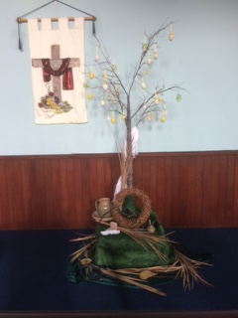On Ash Wednesday I was busy thinking about Easter Sunday and a special Easter service that is being arranged by the Methodist Women in Britain organisation. This sounds a bit in advance or itself, but I have been helping to organise an Easter display photograph that is going to be used as part of this on-line service. The photograph is shown here. And before you ask, no, I’m not a member of the Methodist Women in Britain organisation - even if I am a flower arranger.

Most of us like to keep diaries and wall calendars up to date as reminders for day-to-day activities, meetings, and special events. By keeping diaries, we acknowledge that we need routine and rhythm in our lives to keep us safe and stress free. Others manage to run a computerised diary rather than a paper version, but the technology is too fussy for me to manage.

We don’t need a diary to mark the seasonal changes we see outside with new growth in the gardens giving signs of spring. yet we all try to plan for what’s in store for us, especially birthdays and anniversaries. The church’s year is another form of diary and its main festival of Easter is celebrated across the world as a time to mark the resurrection of Jesus Christ from the dead. This offers all believers hope of salvation and everlasting life. In our bible passage the disciples could not have known what was to come for them all. The amazing event of the empty tomb was totally beyond their imaginations and they just did not know what to expect. Perhaps its good to experience surprises to our daily lives sometimes.

In these strange times, let’s hope that we all get a good surprise about the Covid 19 restrictions being lifted soon.

**Brian Simpson -** DTM Chair and Acting Secretary

**Two Hymns for Easter**

|  |  |
| --- | --- |
| On a hill far away, stood an old, rugged Cross The emblem of suff'ring and shame And I love that old Cross where the dearest and best For a world of lost sinners was slain ***Chorus***  *So, I'll cherish the old, rugged Cross Till my trophies at last I lay down I will cling to the old rugged Cross And exchange it some day for a crown*  Oh, that old, rugged Cross so despised by the world Has a wondrous attraction for me For the dear Lamb of God, left his Glory above To bear it to dark Calvary ***(Chorus)***  To the old, rugged Cross, I will ever be true Its shame and reproach gladly bear Then He'll call me some day to my home far away Where his glory forever I'll share ***(Chorus)*** | There is a green hill far away, outside a city wall, where our dear Lord was crucified who died to save us all.  We may not know, we cannot tell, what pains he had to bear, but we believe it was for us he hung and suffered there.  He died that we might be forgiven, he died to make us good, that we might go at last to heaven, saved by his precious blood.  There was no other good enough to pay the price of sin, he only could unlock the gate of heaven and let us in.  O dearly, dearly has he loved! And we must love him too, and trust in his redeeming blood, and try his works to do. |

**Easter Quiz**

1 On average, how many Easter Eggs do UK children receive each year?

a) 8 b) 12 c) 4 d) 1

2 Which of these ingredients is not traditionally in hot cross buns?

a) Ginger b) Saffron c) Coriander d) Nutmeg

3 The Easter bunny was originally depicted as a hare, but from which European country does he originate?

a) Germany b) Denmark c) Italy d) Wales

4 What does the rabbit in Alice In Wonderland always carry with him?

a) An Easter egg b) A pocket watch c) An umbrella d) A mobile phone

5 What happens to the clocks in spring?

a) They go forward b) They go back c) They all stop d) They’re all replaced with the sound of dogs barking

6 What part of the cocoa plant is chocolate made from?

a) Beans b) Leaves c) Berries d) Flowers

7 Why do many Easter eggs have a crocodile or fish scale design on them?

a) To represent the fish eaten on Good Friday

b) To cover up any imperfections in the chocolate

c) Just to look pretty

d) The design is inspired by a valuable Fabergé egg

8 Eggs have been the symbol of life for centuries. The act of giving eggs as gifts date back to which civilization?

a) Romans b) Egyptians c) Persians d) All of the above

9 How many Creme Eggs do Cadbury make each day?

a) 100,000 b) 500,000 c) 1 million d) 1.5 million

10 Who wrote The Tale of Peter Rabbit?

a) Beatrix Potter b) J K Rowling c) Jacqueline Wilson d) Roald Dahl

11 How long does it take for an egg to fully form before it is laid?

a) Three hours b) 12 hours c) 26 hours d) A week and a half

12 The world’s largest chocolate Easter egg was created by an Italian chocolatier. It was 10.39 metres tall. How much did it weigh?

a) Around the weight of a giraffe b) Around the same weight as a car

c) Around the weight of a large African elephant d) Around the weight of a double decker bus

*(Answers on page 8)*

**Easter Memories**

Many reading this Easter Newsletter will have their own fond memories of Easters in the past. Perhaps you can echo some of the contributions made below from DTM Friends and Volunteers?



“I remember making paste eggs by boiling eggs in onion skins and cochineal. This was in the fifties before chocolate eggs!”

“We always scavenged about the school grounds and made Easter gardens to take home to our families.”

“We would take our decorated hard-boiled eggs to Sugar Hill Park and roll them down the bank - great fun!”



“Every Easter I had a new white cardigan and Clark’s T-bar sandals to wear to church on Easter Sunday”

“I always had a brand-new outfit to be smart at church.”

“My mother would make a simple cake putting the 11 marzipan balls on top to represent the 11 apostles (Judas wasn’t included)”

“As choir boys, we were each paid half-a-crown to sing at all the main church festivals. Most of this money was spent at the sweet shop on way home from church on Easter Day!”

“Looking back, I think that most of my significant memories of Easter have been of re-enactments of the Easter story. As a volunteer at Scargill House I recall Maundy Thursdays when we go after dark to the Walled Garden then follow the path in candlelight to hear the account of Jesus in the Garden of Gethsemane being read. At Lee Abbey we were again in the dark but this time it was Easter morning. I remember the disciples rushing headlong along a path after finding an empty tomb. Another year found us on a fine, but chilly, morning standing in a graveyard on Iona waiting for dawn to break and something to happen, we were not quite sure what! As we watched, the door of the cemetery chapel was struck by a priest, and it opened to reveal a procession of people carrying a huge cross decorated with spring flowers. We followed the procession to the church for the early morning Easter Day service and celebrations. What glorious memories.”

"I remember boiling lots of eggs and painting tiny Disney characters on them for the children. Lots of skill and love went into creating them, and although they were well received, I think the chocolate eggs were the favourites! Incredibly some have survived for 45 years, which cannot be said for the chocolate variety!!"

"Eating my Easter eggs before breakfast and feeling sick for the rest of the day!'

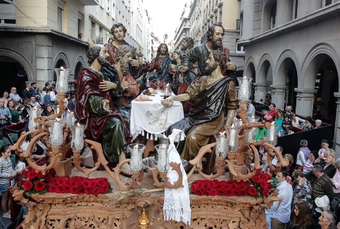***Easter Memories continued….***

“When my parents lived in the south of Spain, I always visited them at Eastertime. This was a special time for my family with a chance to relax and have fun together. The highlight of these holidays was the annual visit to the city of Granada to see the ‘Semana Santa’ (Holy Week) celebrations. The streets were taken over by flamboyant parades and intricate religious displays depicting biblical scenes. You could feel the warmth and love from everyone around you. It was always a magical experience, and I hold these memories in my heart”.

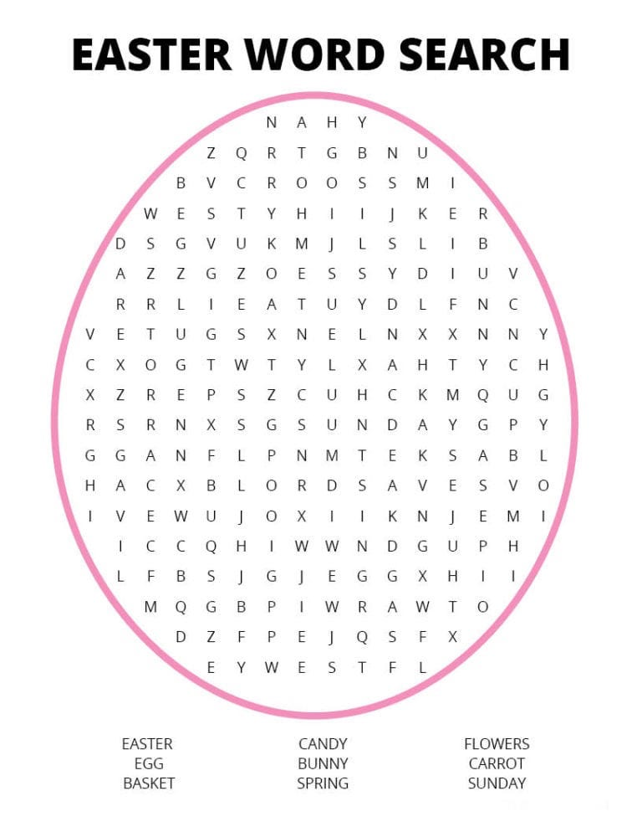

Simnel Cake Recipe

## *(with thanks to the BBC Good Food Guide)*

## ***Ingredients***

* 250g mixed dried fruit (a mixture of sultanas, currants, raisins and candied mixed peel)
* 1 orange, zested and juiced 500g pack marzipan
* 250g pack butter softened 200g light brown soft sugar
* 4 eggs, plus 1 beaten to glaze 175g plain flour
* 100g ground almonds 1 tsp baking powder
* 1 lemon, zested 2 tsp mixed spice
* 1 tsp vanilla extract 100g glacé cherries, halved
* 3 tbsp apricot jam

### ***Method***

* **STEP 1**

Put the mixed dried fruit in a bowl with the orange juice and zest and 2 tbsp water. Cover and microwave for 2 mins, then leave to cool completely. Alternatively, heat gently in a pan, stirring now and then until the liquid has been absorbed and leave to cool.

* **STEP 2**

Heat oven to 150C/130C fan/gas 2. Roll out a third of the marzipan and use the base of a deep 20cm cake tin as a template to cut out a circle. Wrap any offcuts and the remaining two-thirds of marzipan and set aside for later. Butter and line the cake tin with a double layer of parchment. Beat the butter and sugar together until creamy. Add the eggs, flour, almonds, baking powder, lemon zest, mixed spice, and vanilla (all in one go) and mix until well combined. Mix in the cooled soaked dried fruit and fold in the cherries.

* **STEP 3**

Scrape half the cake mixture into the tin. Top with the disc of marzipan, then the remaining cake mixture, and level the top with a spatula. Bake for 2 hrs. Check it’s cooked by inserting a skewer to the centre of the cake, if any wet mixture clings to the skewer, return to the oven for another 10 mins, then check again. Cool in the tin for 15 mins, then turn out onto a wire rack and leave to cool completely.

* **STEP 4**

Brush the top of the cake with apricot jam. Roll out half of the remaining marzipan and use the base of the cake as a template to cut out another disc. Place it on top of the cake and crimp the edges if you like. Roll the remaining marzipan into 11 equal-sized balls for the apostles. Brush the marzipan with beaten egg and arrange the apostles in a circle on top around the outside and brush them with a little egg too. Put under a hot grill for a minute or two until just starting to caramelise – be very careful as the marzipan will burn easily. Leave to cool and wrap a ribbon around the cake if preferred. Will keep for up to a week in a sealed tin.

**An Easter Choicde Quiz - Answers:**

**1.a) 8 2. c) Coriander 3. a) Germany. 4. b) A pocket watch. 5. a) They go forward. 6. a) Beans.**

**7. b) To cover up any imperfections in the chocolate. 8. d) All of the above. 9. d) 1.5 million.**

**10. a) Beatrix Potter. 11 c) 26 hours. 12. c) Around the weight of a large African elephant.**

**DTM and Me**



Fourteen years ago, a few months after my husband died, I was having coffee at the back of St. Edwin's Church at High Coniscliffe after the service and chatting with my friends Sue and Derek Mills. Derek asked me if I had ever thought of becoming a volunteer for Darlington Town Mission? I had never heard of this organisation, so he explained that it was the oldest charity in Darlington, started many years ago to visit and take out very elderly people who were lonely and didn't have much fun.

This seemed a like a good idea, so agreed to give it a try. The next outing was a mystery trip of the volunteers choosing and I was asked to pick up two ladies and take them for a drive somewhere of my choosing and then back to Bondgate Methodist Church for tea and cakes.

I soon found out that tea, or in my case, coffee, was an important part of the outings.

The two ladies I picked up were lovely and it was their first outing too, so we bonded very well. One of the ladies, Doreen, is still a "Friend" as we call them, and we have many a good laugh together especially about men in shorts!!

After that I was asked if I would help with the fortnightly lunch club known as the ‘Friend’s Forum’ which was held in a community hall in town. This was started by the then Missioner, Ann, who has sadly died last year. She was a great person and helped so much with the fund-raising committee and everything to do with the Mission.

I continued helping at Friend’s Forum with several further Missioners all of whom did a great job bringing lovely lunches from home and warming them up in the kitchen when necessary. The mother of one of the Missioners now comes to the lunch when it is on and I have had a couple of lovely coffee mornings in her garden when we could meet outside.

One of our Friends lives in Haughton and the Missioners and I have had coffee in her garden where she has grown a wonderful sunflower which we all admired. Woe betides us if we didn’t mention it!!!

I could write pages more but will end this with the story of Little Sis and Big Sis!! When Sue Case oversaw Friend’s Forum as our previous Missioner, one of the ladies was talking about her sister and Sue expressed her disappointment at not having a sister herself. Brothers are just not the same. Sue said how she wished she had had a sister as she only had two brothers. I’m in the same boat as Sue, so we agreed to call one another Big Sis and Little Sis. We still see ourselves as honorary sisters to this day.

Thank you to all the DTM team and those we support for all the fun and friendship,

**Mary Drury**

**DTM Volunteer and Trustee**

**A Poem of Hope**

Look out of your window, what do you see?

Do you see what I see?

Do you see beautiful buzzing bees?

The grass as green as a lime?

New flowers blooming?

Do you see birds chirping?

Do you feel joy?

From your tiny box, endless creativity?

Mums in hot tubs in the sun?

Do you see dolphins surfing an avalanche?

Crowds of people bungee jumping down Mount Vesuvius?

A baby giraffe floating in space?

And children making igloos on the sun?

You do?

I do too!

And hope becomes reality

When the window becomes a door

And you can throw it wide.

***Daisy Simpson (aged 9) -*** *Heathfield Primary School*

**Another Quiz for Easter**

1. What is the last week in Lent called in the Christian calendar?
2. Which US President started the tradition of the White House Easter egg hunt?
3. From which country does the Easter lily originate?
4. What name is given to the day before Good Friday?
5. What name is given to the last TWO weeks of Lent?
6. On which day are Hot Cross Buns traditionally eaten?
7. Who was Fred Astaire's female co-star in the 1948 movie "Easter Parade"?
8. Easter Island is an overseas territory of which other country?
9. What is the Sunday prior to Easter Sunday known as?
10. Who directed the 2004 movie "The Passion of the Christ", the dialogue of which was entirely in Aramaic and Latin?
11. Which company produced the UK's first Easter egg in 1873?
12. On what animal did Jesus ride into Jerusalem on the first Palm Sunday?
13. When the Roman governor, Pontius Pilate, offered to release Jesus, who did the crowd insist he release instead?
14. The Good Friday agreement signed in 1988 as part of the Northern Ireland Peace process is also referred to as what?
15. Where did the Last Supper take place?
16. Which is the only Shakespeare play to mention Easter?
17. Which of Jesus' disciples denied him three times before the cock crowed?
18. Who on Easter Sunday 2006 became the first incumbent Head of State to reach the North Pole?
19. How many times is Easter mentioned by name in the King James Bible?
20. According to the Gospels who was made to carry the cross of Jesus?

*(Answers on Page 12 – don’t peek)*

**Latest Marketing News**

Our Business Development plan commenced in January 2021 with the publication our first article in the ‘One Darlington’ magazine which has a print of 55,000 copies. This magazine is widely distributed to most homes in the area and is also available at several public locations. It is published every second month and we intend to be a regular contributor. Regular DTM entries in ‘One Darlington’ will be a key part of our overall marketing plan for 2021. This should raise public awareness of DTM and attract further business sponsorship, feature our events and fund-raising promotions and to cover stories and comments from our Friends and Missioners.

We have already secured several generous business sponsors to cover the costs of this and have received some lovely compliments from them:

* *“We are very aware of the way Darlington Town Mission tirelessly help so many elderly residents in our local community and we feel privileged to offer our assistance to help them continue with their excellent work and charitable aims”* - **Real Property UK Ltd**.
* *“Darlington Town Mission carries out some truly fantastic work”-* **Seaton Leng and Son**
* *“Darlington Town Mission has a history of unstinting service to the people of Darlington going back almost 200 years. BHP Law has roots in Darlington since 1835. We are proud to assist the Mission with their wonderful endeavours and work in supporting the elderly in our community*” - **BHP Law**

BHP Law are also adding the DTM logo to their in-house magazine and including an article about their association with us. This will be a wonderful way of gaining publicity for DTM amongst BHP Law clients and the local business community.

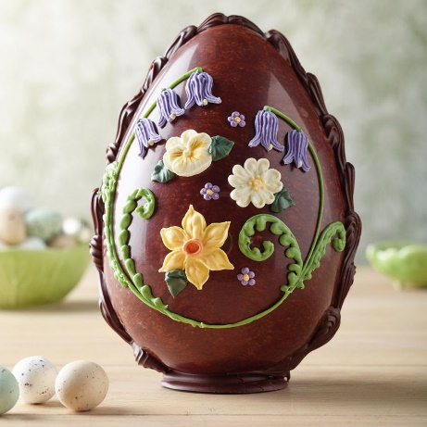

**Another Quiz for Easter – Answers**

|  |  |
| --- | --- |
| 1. ***Holy Week.*** 2. ***Rutherford Hayes in 1878.*** 3. ***Japan.*** 4. ***Maundy Thursday.*** 5. ***Passiontide.*** 6. ***Good Friday.*** 7. ***Judy Garland.*** 8. ***Chile.*** 9. ***Palm Sunday.*** 10. ***Mel Gibson.*** | 1. ***Fry’s of Bristol.*** 2. ***Donkey.*** 3. ***Barabbas.*** 4. ***The Belfast Agreement.*** 5. ***Jerusalem.*** 6. ***Romeo & Juliet.*** 7. ***Peter.*** 8. ***Albert II of Monaco.*** 9. ***Once (Acts 12:4)*** 10. ***Simon of Cyrene.*** |

**Stop Press:**

We have been given two wheelchairs and a four-wheel walker with seat to loan out or give away to anyone that would benefit from this kind donation. They are all in excellent condition and have been purchased commercially (Not NHS). Please contact our Missioners if you need further information - 0794 3251357

**Darlington Support:**

This is a group of volunteers that can still help people who are unable to go out for whatever reason, they collect shopping/prescriptions, they even have people who do companion calls for those who may be lonely and feeling isolated. **Also on offer at present is the arrangement of transport (1AB Taxis) for your vaccination appointment**. The number to ring is 01325 978897 or go to [www.darlingtonsupport.uk](http://www.darlingtonsupport.uk)

***If you have any items for our Summer Newsletter, we would be delighted to hear from you.***

***Please telephone the number below. Thank you.***

DTM founded 1838

Registered Office - 2 Davison Road, Darlington, Co Durham DL1 3DR

Tel 0794 3251357

Reg. Charity Number: 235572

*‘We aim to provide relief from isolation and loneliness in the elderly by visiting, providing social contact and Christian Fellowship.’*

[www.darlingtontownmission.org.uk](http://www.darlingtontownmission.org.uk)