

**Annual Report**

**Year ended 31st December 2019**

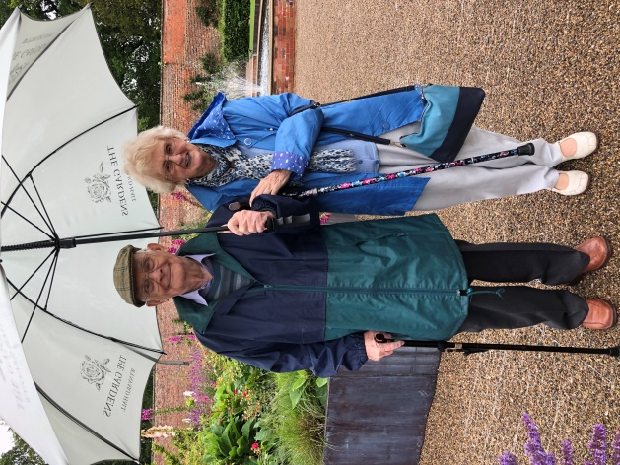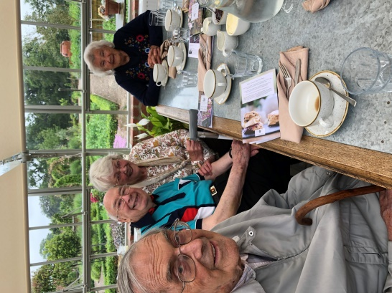

**Geoffrey, Neville, Sylvia and Ivy Ken and Joan**

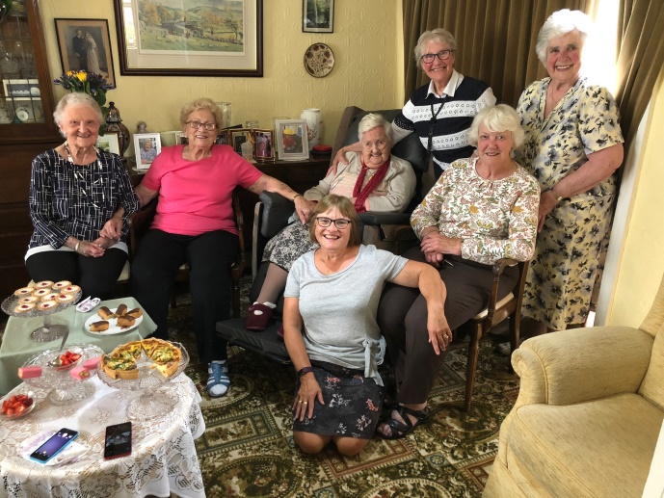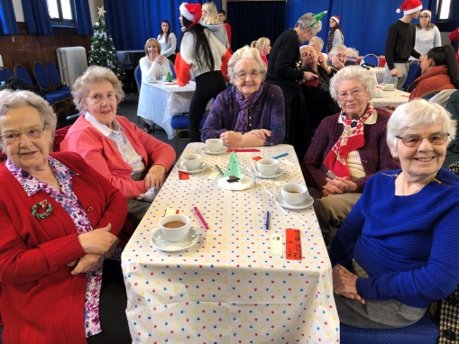

**Friend’s Forum**

**Molly’s Party Time at Q E 6thForm**

**Darlington Town Mission**

Tel: 0794 3251357

Founded 1838

Registered Office - 2 Davison Road, Darlington, Co Durham DL1 3DR

Reg. Charity Number: 235572

*‘We aim to provide relief from isolation and loneliness in the elderly by visiting, providing social contact and Christian Fellowship.’*

[www.darlingtontownmission.org.uk](http://www.darlingtontownmission.org.uk)

## REPORT FOR THE YEAR ENDED 31 DECEMBER 2019

page

**Contents** 2

**Achievements and Appreciation for 2019**  3

What we do? 3

What are loneliness and social isolation? 4

Chair’s message 6

Vice-Chair’s letter 8

Missioner’s review of the year 2019 9

Assistant Missioner’s message 11

Friends’ reflections 12

A Volunteer’s perspective 13

How you could support us 15

Other organisations that support us 16

Good News about new Branding and Website 17

A message from Sue Case 19

**Coronavirus Information**  *as at March 2020* 19

Prayer Page 20

### Our Vision

Is to reduce isolation and provide companionship.

### Our Beliefs

That every person is entitled to a good quality of life through fellowship and social support which combats isolation.

### To achieve this we normally:

### Carry out home visits

* Provide companionship to our Friends individually or through a busy program of group social events supported by a wonderful team of volunteer drivers
* Provide acts of worship
* Provide a fortnightly lunch club for a small group of Friends

**Achievements and Appreciation for 2019**

### Last year the Mission:

### Made 1,320 visits or individual outings for Friends relieving isolation, providing support and encouragement and helping them with practical tasks.

### Took 436 Friends on monthly group outings and special events.

### Helped our Friends with support and transport for medical appointments and practical help where resources allowed. We keep in telephone contact with many of our Friends.

### Continued our very successful fortnightly Friends Forum which provides lunch, activities and social interaction.

### Took Friends on small group outings and individual Friends to meet with their friends, or enjoy an occasional lunch or coffee with them.

### We have continued our monthly services in two care homes. The residents enjoy hymn singing, prayers and reflections.

### Took Friends to services at ‘The Well’ which is a new Methodist Church building based in the old Northland Methodist Church in North Road for their fortnightly lunch club.

### Recruited three excellent new volunteers.

**What we do**

**The Charity**

TheDarlington Town Mission was founded in 1838by three local businessmen - John Backhouse and John Pease who were well known Quakers and John Hopkins, an Anglican.

Its aims are as follows:

* To relieve poverty, sickness, hardship and distress of those in need in the Borough of Darlington through the provision of practical and material assistance, information and support and by any other charitable means that the Trustees in their discretion think fit, in order to improve the said beneficiaries’ quality of life.
* To advance the Christian faith particularly but not exclusively by holding services of worship where appropriate.

These aims are achieved in the following ways:

* The Mission employs Missioners who work with a number of volunteers
* Visit people in their homes and in hospital to offer practical and material assistance, information and pastoral support
* Arrange trips out and other social events
* Through exemplifying Christian love and service in the work we do, as well as arranging acts of Christian worship

We are now focusing our activities on relieving loneliness and isolation in the elderly in Darlington. All our charitable activities focus on improving quality of life and are done to further our charitable purpose for the public benefit.

**What are Loneliness and Social isolation?**

Loneliness is a subjective, negative feeling experienced where there is a discrepancy between the amount and quality of social contacts one has, and the amount and quality one would like to have. It is related to but distinct from social isolation which is an objective state, the absence of social contacts and social connectedness.

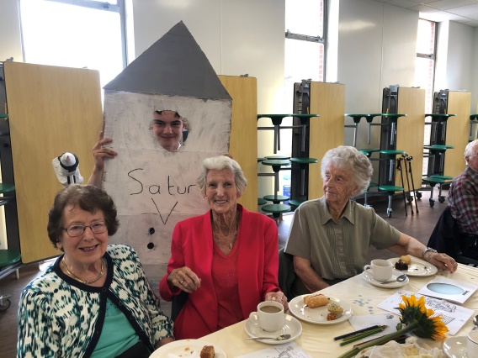

**What are the intrinsic factors?**

Lack of transport; not living near families; bereavement; becoming a carer; experiencing poor health or poor mobility; loss of sight or hearing; being childless and living on a low income are all factors which can cause a person to become lonely.

Loneliness is seen by many as one of the largest health concerns we face. Why? Here are the facts.

## Health risks

* Loneliness, living alone and poor social connections are as bad for your health as smoking 15 cigarettes a day. (Holt-Lunstad, 2010)
* Loneliness is worse for you than obesity. (Holt-Lunstad, 2010)
* Lonely people are more likely to suffer from dementia, heart disease and depression. (Valtorta et al, 2016) (James et al, 2011) (Cacioppo et al, 2006)
* Loneliness is likely to increase your risk of death by 29% (Holt-Lunstad, 2015)
* Loneliness has a significant impact on our wellbeing and mental health.

## Loneliness and older people

* The number of over-50s experiencing loneliness is set to reach two million by 2025/6. This compares to around 1.4 million in 2016/7 – a 49% increase in 10 years (Age UK 2018, All The Lonely People)
* There are 1.2 million chronically lonely older people in the UK (Age UK 2016, No-one should have no one)
* Half a million older people go at least five or six days a week without seeing or speaking to anyone at all (Age UK 2016, No-one should have no one).
* Over half (51%) of all people aged 75 and over live alone (Office for National Statistics 2010. General Lifestyle Survey 2008).
* Two fifths all older people (about 3.9 million) say the television is their main company (Age, U.K., 2014. Evidence Review: Loneliness in Later Life. London: Age UK).
* There are over 2.2 million people aged 75 and over living alone in Great Britain, an increase of almost a quarter (24%) over the past 20 years (ONS).]
* 4.75% of 106 thousand residents in Darlington are 81 or more.

Most of us will feel lonely at some point in our lives, but many are brilliant at hiding it or even admitting it. Our charity provides a vital lifeline of companionship, Christian fellowship and practical help to many elderly people in Darlington. We help to relieve loneliness by visiting people in their own homes and in care homes. We help by giving older people the chance to join with others in outings, social and other events and at our Friends Forum which provides fortnightly lunch and activities for a smaller number of Friends.

The charity also provides a spiritual dimension in providing access to Christian fellowship and ecumenical worship. For those Friends who are Christian we aim to nurture them in their faith, and for those of other faiths or none, to support them equally in our caring.

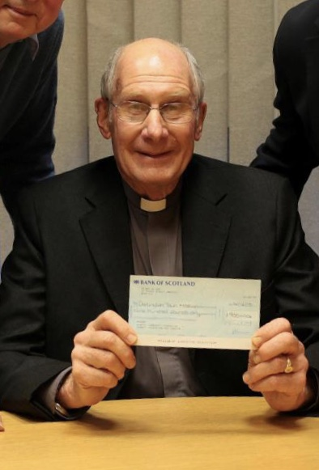**Chair’s Annual Report 2019**

First, and most important, a big word of thanks to all who offer themselves to support the Town Mission as volunteers. This comprises a number of ways: office holders, trustees and committee members, fund-raising, driving and visiting. We are so blessed to have such a reliable team, some of whom have been committed to DTM for many years, but also how good that new volunteers are coming on board - so vital for the on-going life and effectiveness of our caring mission. For those who recognize that their days of effective service are drawing to a close I want to say a special thank you on behalf of the Mission as a whole. So many Friends and fellow volunteers have received so much from your contribution - and your person! - That it must be that we put our thanks on record!

2019 has been a great year for our Friends from the care they have received from our Missioner and now Assistant Missioner - Hilary Reaney who joined us for the last part of 2019 as part time Assistant Missioner. She has quickly found her feet to the pleasure of her new-found Friends! Sue and Hilary are proving themselves to be an exceptional team in the ways they look after Friends and their individual needs. It is striking how much detailed attention and personal concern they give, especially to those Friends with particular difficulties. It is truly touching to recognize how willingly they will go the second mile; yet at the same time remain within their mandate of befriending without being pulled over into what rightly belongs to NHS or Social Services. Thank you, Sue and Hilary, for all the energy and thoughtful support you have given to so many. Along with the Friends we want to put into words how much we appreciate it!

2019 has been a successful year fund raising. Once again I express the Trustees’ warm thanks for all the ongoing efforts that go into raising the finance required for the Mission to operate as it does. The Fund-raising committee is to be commended for another year of unremitting attention and fruitful fund-raising events. When most of us would thankfully be rewarded with a sabbatical year off, the FRC has continued in good heart - small in numbers but generous and loyal in spirit! What a blessing to us all!

I must also mention Julia Bean’s amazing achievements in her complementary fund-raising events. What the right hand can’t gather is harvested by the left! It is most certainly to our huge benefit to have a Trustee that focuses on our marketing with a heart to give herself to what the Town Mission is about. Thank you, Julia!

Just a thought about Darlington Town Mission -It’s not many that can say, ‘In 18 year’s time we will be 200 years old!’ Charities don’t just happen; nor are they kept alive by a company that pays huge salaries to their directors, nor are we a part of governmental structures. No, every charity at root is a body of like-minded charitable people who believe in a good cause and are willing to give themselves to it - without seeking payment. In the true sense of the word they are ‘amateurs’ (they do it for love!) So we find ourselves a year older: and we might ask: ‘How is it that we still keep going?’ Answer: Not because we have employed our office holders to dedicate themselves for 25 years. Not because each trustee, each committee member, each volunteer has signed a pledge to commit to us for 10 years (!) - nothing of the sort! We engage with the goodwill of all our volunteers, be they officer-holders, or be they cake-makers! We depend on what is the heart of the word ‘charity’: love - not the warm feeling, but the commitment to give ourselves for the good of all DTM stands for - essentially the well-being of our Friends. So, thank you to you who keep DTM on the rails - who fulfil all that the Charity Commission requires of every registered charity.

Finally a big thank you to our Secretary and our Treasurer. Where would we be without you? Thank you Brian and Derek!

With every blessing for the coming year,

***Revd. Andrew Wigram***

***Vice-Chair’s letter***

First of all, I’d like to thank Darlington Town Mission for the privilege of serving another year as a Trustee and as the charities’ Vice Chair. This last year I’ve had the extra duty of acting as secretary to our management meetings and to the Trustee meetings. We are currently seeking volunteers to take on the secretarial work; to help Derek with some of the book-keeping; to support the work of our Fund Raising Group and looking out for more volunteers to support outings, home visits and care home worship. Like many charities, we face an uphill struggle to find volunteers that are available now that the retirement age seems to be creeping up and up.

The other news is that we have been given generous legacies from the estates of three Friends that have paid for a set of better hymn books to use in worship at care homes and elsewhere. Once the current Coronavirus crisis is over these will be used in care home worship and on many other occasions. Each of the hymn books, a set of CD’s and a musical accompanying book contain the bookplate shown here:

*Donated in memory of three wonderful Christian ladies and Friends,*

*all of whom supported and benefited greatly from Darlington Town Mission over many years.*

***Marion Barron, Edna Bussey & Margaret Price***

***We aim to prevent, and provide relief from isolation in the over 80s by visiting, providing social contact and Christian Fellowship***

We continue to be blown away by such generous gifts and all the amazing support we receive from the Fund Raising Group and so many companies, schools and colleges and individuals. Without this help we could not offer the same level of care to our Friends.

With every blessing,

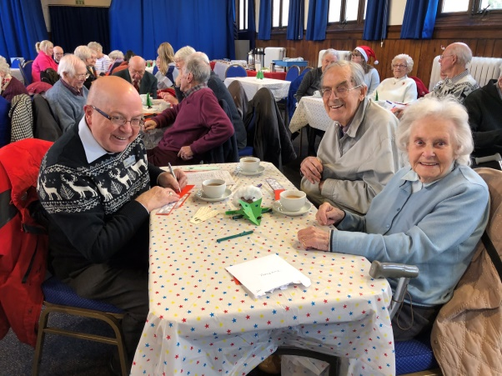

***Brian Simpson***

*Because of the Coronavirus outbreak and government guidelines the Annual General Meeting in April has had to be cancelled. For charity commission purposes, we will be arranging an alternative AGM on 30th June which will have to be take the form of a proxy electronic or postal system.*

*The Annual Thanksgiving Service has also had to postponed.*

*BS 28.3.20.*

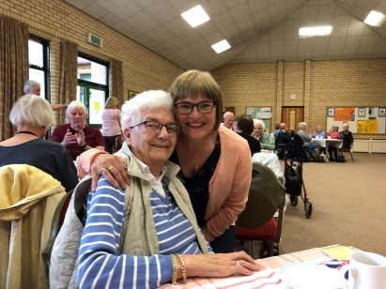**Missioner’s Review of the Year 2019**

As I reflect on my second year as Darlington Town Missioner, I feel both privileged and blessed.

It’s been wonderful to serve through offering friendship, companionship, social outlets, encouragement and a listening ear to those who need us. Sometimes it is practical help that is needed in varying forms and often it’s just a phone chat with our friends that really helps.

So many times I arrive to visit a Friend just at the time they are in need of help and support and this I absolutely feel is God’s guidance and provision. To quote Friends:

*“I believe God sent you to me today”*, and *“You’re an angel sent to help me today*”, and *“You’ve come just at the right time”*, and *“You were meant to come here today”.*

Since becoming Missioner I am very aware and proud that I follow in the footsteps of many who have gone before me over the last 182 years serving those in need in the Borough of Darlington. Loneliness and a need for companionship and friendship are as evident as they always were over the years. Even more so now as family often have moved away or work during the day and our Friends have reached the stage in life that those close to them may have passed away.

We can’t fully define loneliness as everyone feels and copes differently and it can’t be seen or measured. It affects those in all walks of life and even though some of our Friends are able to get out themselves a little, they are in great need of and value social company rather than being always on their own.

Darlington Town Mission provides this valuable contact and support through visits, outings, services, lunches and so much more. This is where real friendships are formed and built upon and where we aim to give hope, purpose and value to the lives of those we serve.

We have issued an outing list for 2020 and our Friends are looking forward to attending events as they are able in the months ahead.

For some of our Friends it’s easier for them if we arrange 1 to 1 or small group outings.

For some they are unable to go on outings now for varying reasons and we continue to visit them which they greatly appreciate. Visits are so enjoyed by myself and Hilary and are real times of blessing and such a valuable source of contact and support to our Friends.

Visits are made at home, in care homes, and to hospital for example. Some of our Friends have deteriorating memory and awareness of who we are these days, but we continue to visit and offer them the hand of friendship and companionship and it’s wonderful to receive a welcome and a smile in return.

Queen Elizabeth College, Polam School, All Saints Church, Rotary and the Lions continue to provide events for us and support to DTM and our Friends through gifts, parties, services, and afternoon teas etc. Their support is so appreciated by everyone in the Town Mission family.

We were invited to bring a few of our Friends to Croft Church of England primary school in November for a party and tea and it was so lovely again to see young and older sharing stories and having fun together.

Worship is a very important part of our Christian witness and we continue to hold monthly services in both Elderwood and North Park care homes. These acts of worship are long established and much appreciated and enjoyed by the residents. We are very thankful to those who lead worship and help out at these services which we greatly value and cherish.

This year we have purchased new hymn books and CDs with money kindly donated to us in memory of three of our wonderful Christian Friends who passed away last year.

We also continue to take some of our DTM Friends to The Well Methodist Church on North Road (previously Northland Church) for an act of worship once a month and fortnightly lunches.

Friends Forum meets at Park Place Community Centre fortnightly, and provides lunch, friendship and valuable company. This is much enjoyed and it’s so lovely to see how much our Friends support each other in this group and hear life stories shared.

In September our wonderful Hilary Reaney started work as our Assistant Missioner, having previously been a volunteer. She has made such a huge difference to me and to our Friends and we are truly blessed by her. Thank you Hilary for all you are doing!

Finally thank you to all our fabulous volunteers who make all we do possible! You are much appreciated by me, Hilary and our Friends.

Special thanks as always to Sue Case who helps and encourages Hilary and me in our work in so many ways.

As always, if Friends need a visit or a chat please contact myself or Hilary.

**Sue Allison**

Missioner

**A message from our Assistant Missioner**

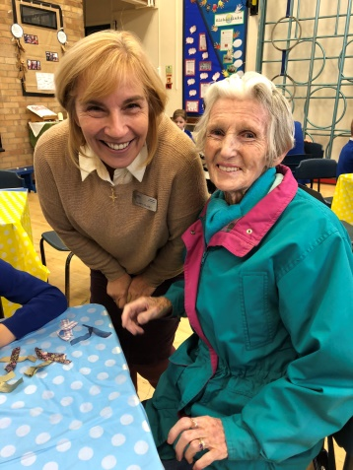Sue has reflected on the past year so eloquently and captured the true spirit of Darlington Town Mission, and all it represents and strives to do for our Friends.

I would just like to add my personal thanks to everyone for the wonderful welcome I have received since becoming Assistant Missioner last September. This includes:

* Our hardworking fund-raising committee, without whom we couldn’t provide the outings, events and other vital support that our Friends so enjoy and appreciate so much.
* Our trustees and management team who have shown their faith in me and offer continuing support.
* Sue Case and Brian Simpson who never cease to amaze me with their generosity of spirit and all their hard work which is often done behind the scenes.
* Of course I have a wonderful role model in our Missioner, Sue Allison. Thank you Sue for your guidance, support, encouragement and special friendship.
* To all our Friends who make my role such a pleasure, for your welcome, your trust, the laughter and your wisdom. Thank you. It is a privilege and blessing to know you.

I would encourage anyone to become a volunteer with Darlington Town Mission. The difference you can make to the lives of our Friends and in turn to your own life will make your soul sing!

**Hilary Reaney**

**Assistant Missioner**

**Some Reflections from Friends and Relatives for 2019**

We have been able to improve our Friends quality of life by combating loneliness and isolation, rebuilding social contact, providing physical exercise and giving practical assistance. These messages of appreciation have been sent in for this annual report booklet. We thank all those that contributed to this section.

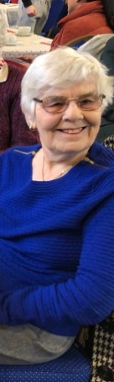

**Daughters of Audrey Anderson -**

*“Who knew that an outing once a month would make such a difference to an elderly lady? A cup of tea, piece of cake (amongst other wonderful and varied activities) and being welcomed by a group of similar aged people has given our mum something to look forward to and talk about. Thank you Sue and Hilary from the bottom of our hearts. You will never know how much we value your efforts on behalf of all the Friends not just (but most especially) our mum”.*

**Iris McFall -**

*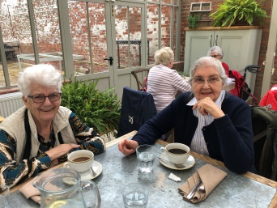“Meeting Sue Allison the Missioner for DTM nearly two years ago has made a tremendous difference to me ,being taken out to new places, doing new things with interesting ,caring, happy people every month. Thank you Sue and co. for being there for me. I hope when you are older you will have the same friendship and support that I have found through DTM. God bless”*

*Iris on the right at Wynyard Hall*

**Ken Friston -**

**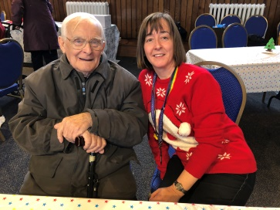***“I was treasurer of DTM for over 11 years and have since then always supported as a member of DTM. However over this last year I have been a Friend and really appreciate the difference visits and getting out in company makes and it gives me something to look forward too”*

**Neville Town -**

*****“I have been involved with DTM for over 10 years, as a volunteer driver, a former trustee and now am delighted to be included among the Friends. DTM was formed over 180 years ago to help the poor and those in distress and today it continues to provide help, fellowship and combat loneliness. If I was asked the question, “”What does DTM mean to me?””, I could sum it up in one word.....”Joy!”*

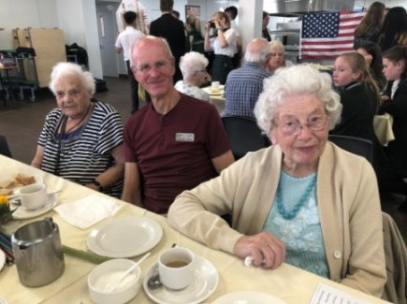**A Volunteer’s Perspective**

For whatever reason, whenever I become involved with a charity or other voluntary organisation I seem to be on the committee, ending up as treasurer, secretary or chairman. So, a few years ago, I made a positive decision to play a coal face role in a couple of Darlington initiatives, ensuring that I stayed a pure helper and nothing more. One of the initiatives was Busy Readers (look it up, if you need to) but that is another story. The other was Darlington Town Mission.

Why DTM? I guess for two reasons. The first was that, during the time when I was living in Norfolk, I became involved (as chairman, of course!) with a charity that took disabled people out and about. We had a converted coach, but the concept was similar to the part of DTM’s work that involves drivers like me. The second reason was that, at one time, DTM’s office was in my local church (then Grange Road Baptist Church), so I got to know a little about what went on.

I knew the job spec involved taking people on social outings. You get told who to pick up and when, you do your outward taxi stint, you have a cuppa and you then gather up your ‘fares’ for the homeward leg. There is one outing a month, with extra ones thrown in, especially at Christmas. The outings are mostly on a Tuesday, Wednesday or Thursday afternoon. Of course, there are times when you have to say, “Sorry, but I can’t do this one”. All simple enough but it wasn’t long before I discovered that there is rather more to being a volunteer driver than I had anticipated. Let me mention just four things.

Coal faces workers cannot operate without someone to guide them. DTM has been blessed, during my time as a driver, by two amazing Missioners – Sue Case and, latterly, Sue Allison. Both are such angels that I am sure that, on occasions, I can actually see their wings. The work of the Missioner involves far, far more than organising the likes of me, but both Sues have gone out of their way to make me feel valued and appreciated and, above all, part of ‘the family’ rather than someone who is there to perform a duty. I have no doubt that everyone else involved with DTM will share that view and what a difference it makes.

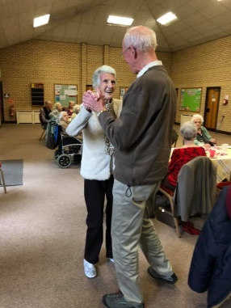I learned quickly that the outings were very much about the food and drink. There might be a notional, ten minute look around a garden centre (it is usually a garden centre as they have the facilities to accommodate however many of us there are), but those I have taken on outings seem to have a sixth sense when it comes to knowing the quickest way to the tea shop! And they remember. “Last year the chocolate cake was a bit dry, so I hope it will be better this year” or “Make sure you have a fruit scone; they really are good”. I often think DTM people would make great TripAdvisor reviewers on Facebook!

When not at a garden centre or, in August, at the seaside, I tend to find myself heading for Polam School or the Sixth Form Centre. Both educational establishments lay on a de-luxe spread, with entertainment. The effort that goes into creating a party atmosphere is clear enough, but what makes it for me is the interaction between the scholars and people old enough to be their great grand-parents. It is fascinating to act as a fly on the wall while the interchanges are going on. Both young and not quite so young gain from the experience and I find myself thinking that the kids of today deserve more credit than they often receive. Full marks to DTM for enabling this little bit of communication that has an inter-generational theme.

Finally (and I have saved the best for last), there are my ‘passengers’. It is difficult to say how much I have gained from being with them. I can’t help but smile when they are exchanging ages and one admits to being “only ninety-one”. They have taught me so much local history about Darlington and the surrounding areas. And the personal stories they have to tell, often about the Second World War years, are amazing. They are as bright as a button and always concerned to know that I am okay and that whatever issue I was facing when I last drove them on an outing has been sorted. Wonderful people and, thanks to the Sues’ organisational talents, I have got to know all of them during my few years as a driver.

After 25 years in Darlington but for very good family reasons, I am about to return to Norfolk and must say ‘Goodbye’ to DTM. I do so with a great feeling of sadness, but I know that I shall carry DTM and those involved with it in my heart for the remainder of my life.

If you are reading this, own a car and are perhaps, wondering about doing a little something for the local Darlington community, I encourage you to sign up as a volunteer driver with the Town Mission. You won’t regret it – far more than that, you will love it and grow in the process.

With every blessing for the future of Darlington Town Mission,

**David Rose**

**HOW YOU COULD SUPPORT US?**

**a) Volunteering opportunities**

We could not provide the service we do without the input of our volunteers. They provide invaluable assistance across the board from visiting our Friends, driving and accompanying them on outings, and in participating in our monthly care home acts of worship. We are so grateful to them for the time and effort they put in and we do our best to make sure their involvement is both fulfilling and rewarding.

If you would you like to join as part of our pool of volunteer drivers who take our Friends on monthly outings organised by our Missioner, or if you would like to relieve the loneliness of elderly people by spending a couple of hours a week visiting, please call our Missioner on 07943251357 or email [missioner@darlingtontownmission.org.uk](mailto:missioner@darlingtontownmission.org.uk) for further information. With your help we could enrich many more elderly people’s lives. We would love to hear from you.

**b) Financial support**

# [To continue and expand our services we rely on the generosity of individuals, churches and groups. If you wish to donate you can do so on line at:](http://www.localgiving.com/darlingtontownmission)

# [www.localgiving.com/](http://www.localgiving.com/)[darlingtontownmission](http://www.localgiving.com/darlingtontownmission) [or send a cheque to our address or email us at](mailto:%20or%20send%20a%20cheque%20to%20our%20address%20or%20email%20us%20at%20) [treasurer@darlingtontownmission.org.uk](mailto:treasurer@darlingtontownmission.org.uk) for details of other means of giving.

# You can even raise funds for us by shopping online using the amazing website that supports charities like ours. It costs you nothing at all, simply go to [www.giveasyoulive.com](http://www.giveasyoulive.com) and:

1. Sign up choosing Darlington Town Mission as your chosen charity
2. Choose from over 4,200 stores to shop with
3. Click through to the store from their site & shop as usual
4. They donate a % of your spending to us - for free!

If you interested in helping with our fundraising you can join our Fundraising Team. They are currently seeking extra people with fund raising knowledge to help out.

Please contact us for more details or if you wish to do a sponsored fundraising event for us you can open a fundraising page on our local giving website as above.

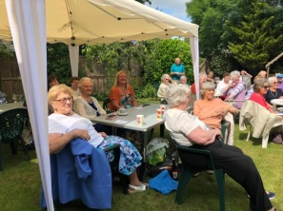

**OTHER ORGANISATIONS THAT SUPPORTED US IN 2019**

The Missioner has been engaging with other groups working with older people, exchanging ideas and practices. The Mission would like to thank the following organisations and individuals:

**Haughton Methodist Church** for hosting the Mission’s Annual Service and Carol Service and for helping with the refreshments afterwards

**St Thomas Aquinas Roman Catholic Church** for hosting our quiz fundraising event

**Harrowgate Hill Methodist Church** for arranging and hosting our Burns social afternoon in January

**All Saints Church** for hosting our Fourum concert fundraiser

**Cockerton Methodist Church** for hosting our Come and Sing fundraising event and to members, Carl and Alma Ottolini, for donating the proceeds of their recent quiz to us

**‘The Well’ Methodist Church** for inviting some of our Friends to share in their fortnightly lunch club and their monthly acts of worship beforehand

**St Augustine’s Roman Catholic Church** for hosting our musical afternoon and tea and our Annual Service of Thanksgiving

**Churches of various denominations** for the support they give to the work of the Mission and individuals who have supported us financially

**Whitehouse Funeral Service** for kindly donating the proceeds from their Christmas tree of remembrance and their Christmas service to the Mission

**Rotary Club of Darlington** for their Annual Service on Palm Sunday, followed by afternoon tea provided by the Ladies of the Inner Wheel

**Sugar Craft Guild of Darlington** for the decorated Christmas cakes they donate to the Mission. These beautifully decorated cakes are much appreciated by our Friends

**The Lions Club of Darlington** for donating plants at Christmas. They cheer up our Friend’s winter months. Also for inviting DTM Friends to their Christmas Party at Elm Ridge Methodist Church

**Business and Social Clubs -** We receive support from many other businesses and clubs including the Co-op and Sainsbury’s

**Park Place Community Centre** for accommodating the Friends’ Forum and other events

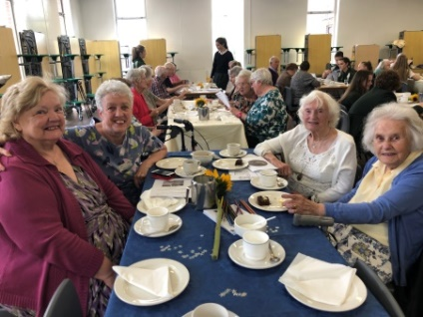**Polam Hall School** that hostedthe 75th Sunshine Summer party and a Jack Frost party at Christmas. The Mission’s link with Polam Hall School is long standing and to our mutual benefit. Twice a year the school’s older students arrange entertainment, an afternoon tea and gifts for the Mission’s Friends. The young people seem to enjoy meeting our Friends and volunteers.

These occasions also offer the young people an excellent opportunity to plan and work as teams so that the parties run seamlessly. Such skills are extremely relevant in today’s society and the outcome fills each student with a real feeling of job well done. The young people talk afterwards about their Town Mission guests and how much they have enjoyed hosting them. We know that their efforts are greatly valued by our Friends and volunteer drivers alike.

Both the above events are very popular with, and much appreciated by our Friends, not only for the fun and entertainment they provide, but for the wonderful refreshments they serve. The parties are a great chance for the chance Friends have to talk to the students when they sit down to tea together. A real inter-generational event!

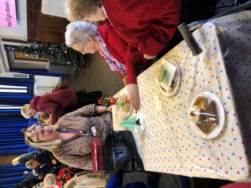**Queen Elizabeth Sixth Form College** invited us to their Christmas event where our Friends played ‘pass the parcel’ and enjoyed a quiz.

We were also entertained with songs and poems by a choir from Dunn Primary school. Our Friends had a wonderful lunch and even went home with Christmas presents. Thanks were expressed to all the staff and Travel and Tourism students involved.

**Croft Church of England Primary School** for inviting a few of our Friends to their school to meet the children, have tea and be entertained. A new venture that would be great to expand on.

**Good News about our new Website and Re Branding**

**In April we are launching our new website along with a newly designed Darlington Town Mission logo which you may have already noticed on the first page of this report.**

**The new website is designed to:**

* **Help raise awareness of our charity by better communicating our values and work**
* **Showcase some of our “Friends” and volunteers to talk about what Darlington Town Mission means to them**
* **Allow visitors to easily navigate the website and access any required information and keep up to date with the latest news and events**
* **Allow elderly visitors to learn more about our services and how to access them**
* **Recruit new volunteers and give information on our volunteering opportunities and sending us their contact details**
* **Allow businesses, schools, colleges, sports and social clubs to learn more about supporting us either through sponsorship, fundraising or volunteering**
* **Share stories about our “Friends” and encourage the wider community to get involved**
* **Encourage visitors to make a donation shop with ‘Give as You Live’**
* **Promote our association with the Co-op**
* **Thank all our supporters**
* **Make everyone involved with our charity proud.**

***A message from Sue Case***

*Well here we are day one of the new curbs to try and beat the Coronavirus. This is a learning curve for everyone out there. Here at DTM we hope it will give everyone a better understanding of how it feels to be lonely and isolated. We are one of many charities whose aim it is to try and alleviate loneliness in the elderly in Darlington, and we have found that it has been hard to get people to fully understand what it is like to feel lonely and isolated. However, due to this virus, we are all sadly being put in a position where we are no longer able to get out, do what we’re used to doing and meeting others.*

*Let’s hope that when we eventually get through this, more people will understand why there are charities like ours and more will be prepared to give up their spare time to help the ongoing battle against loneliness.  
 Sue. 23rd March 2020*

# ****Additional Information Concerning the Coronavirus Emergency****

Since the onset of the Coronavirus outbreak the normal activities of Darlington Town Mission have been affected dramatically. All our fund raising events, monthly outings, Friends Forums and business meetings have been suspended. The amazing amount of home visits carried out by Sue and Hilary and volunteer visitors have also been curtailed. All of the Friends that we care for are over 70 years of age and many with pre-existing medical issues. This means that they are unable to leave their homes other than for urgent shopping or medical appointments.

However, the charity continues to give comfort and support by telephone calls and providing a limited amount of shopping services. When DTM staff and volunteers meet our Friends they have to follow government guidelines for hygiene and infection control guidelines illustrated on the [BBC's video](https://www.bbc.co.uk/news/av/health-51722269/coronavirus-how-do-i-protect-myself) and included under [How to avoid catching or spreading Coronavirus](https://www.nhs.uk/conditions/coronavirus-covid-19/)’ on the NHS website. This includes frequent hand washing and the use of hand sanitizers before and after delivering shopping and social distancing i.e. avoiding being less than two metres away from Friends as they deliver shopping.

As far as possible our Friends should pay for their shopping by cheque but payment arrangements should be agreed in advance with the Missioners or volunteers.

If Friends are taken for medical appointments, visits to banks or building societies, they should use the back seats of the car and avoid physical contact with the driver. Taking Friends on shopping trips may be an unnecessary risk for them and for the drivers. Keep safe and stay healthy. We need to keep a special eye on any government guidelines that are set down over the weeks and months ahead. Stay safe.

***DTM Secretary 9th April 2020***

***Some prayers to use at this most difficult time***

|  |  |
| --- | --- |
| Keep us, good Lord, under the shadow of your mercy in this time of uncertainty and distress. Sustain and support the anxious and fearful, and lift up all who are brought low; that we may rejoice in your comfort knowing that nothing can separate us from your love. **Amen.** | Lord Jesus Christ, you taught us to love our neighbour, and to care for those in need as if we were caring for you. In this time of anxiety, give us strength to comfort the fearful, to tend the sick, and to assure the isolated of our love, and your love  **Amen.** |
| God of compassion, be close to those who are ill, afraid or in isolation. In their loneliness, be their consolation; in their anxiety, be their hope; in their darkness, be their light; **From one who is ill or isolated** O God, help me to trust you, help me to know that you are with me, help me to believe that nothing can separate me  from your love revealed in Jesus Christ our Lord. ****Amen.**** | Merciful God, we entrust to your tender care those who are ill or in pain, knowing that whenever danger threatens your everlasting arms are there to hold them safe. Comfort and heal them, and restore them to health and strength; through Jesus Christ our Lord. **Amen**. |
| Gracious God, give skill, sympathy and resilience to all who are caring for the sick, and your wisdom to those searching for a cure. Strengthen them with your Spirit, that through their work many will be restored to health. Amen. | 'The Lord is near. Do not be anxious about anything, but in every situation, by prayer and petition, with thanksgiving, present your requests to God. And the peace of God, which transcends all understanding, will guard your hearts and your minds in Christ Jesus.'*****Philippians 4: 6 -7***** |